**Learning Flux Balance Analysis from a toy metabolic model**

In this exercise, you will learn the basics of FBA and apply it to resolve fluxes in a small toy network. You will understand how the assumptions and inputs influence the flux prediction outcome.

***Please, answer to the following questions, and write your answer below each point.***

1. What is the main assumption of FBA?
2. What are the 3 inputs required to perform FBA of a metabolic network?

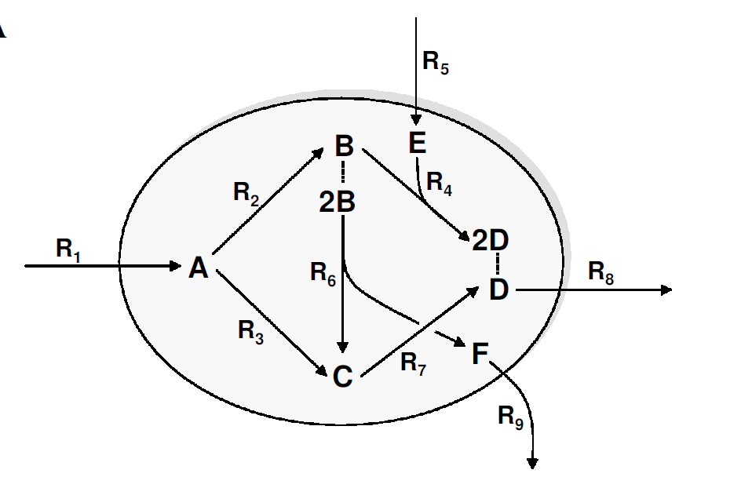

1. (Pen and paper) The above toy metabolic network contains 9 irreversible reactions. The enzyme capacities of reactions R1 and R5 are limited to a maximum of 10 mmol/gDW*h-1 each, while the other reactions are not limited.
   1. We assume that the resources (R1 and R5) are given, and the cell maximizes the extracellular production of the metabolite D (R8). What will be the optimal distribution of fluxes in this case?
   2. What changes will happen if the metabolite E disappears from the environment?
   3. The simulated organism is evolved to maximize the production of metabolite D. If you are doing metabolic engineering in the lab, what can you do to force this organism to also produce metabolite F?
   4. How will the production of metabolite D change if the rate of the enzyme catalyzing reaction 5 is halved?
2. (Pen and paper) Write the stoichiometric matrix of this model. Each row corresponds to a metabolite; each column corresponds to a reaction.
3. Now you will simulate the toy model in MatLab. The script ToyFBA.m is already prepared to help you perform the following tasks. Please, read the comments in the file and try to understand the meaning of the variables: S, lb, ub, obj. Edit the file by defining the values for these four variables according to the model in 4.
4. Run the script ToyFBA.m to solve the optimization problems defined in 4a, 4b, 4c and 4d*. Compare the resulting flux distributions with the distributions you predicted manually in exercise 4. In case of differences, who did a better job in finding the optimal solution?

*Hint: you have to change the upper bounds of reactions accordingly.

1. In order to resemble a more realistic metabolic model let’s assume that R1 is a glucose transporter, R5 takes up oxygen and R9 secretes succinate. Now, imagine that you have performed an experiment and measured physiological parameters of the microorganism:   
   glucose uptake (R1) = 10 mmol/gDW*h-1,  
   oxygen consumption (R5) = 0 mmol/gDW*h-1   
   and growth rate (R8) = 5 mmol/gDW*h-1 .

You immediately realize that the FBA prediction does not match your experimental data.  
How could you constrain the FBA model so that it fits the experimental data? What are the effects of using these new constraints and how would you validate the new predictions made by FBA?

1. Let’s now assume that glucose uptake is performed by an active glucose pump. To import one molecule of glucose, the pump needs to hydrolyze one ATP molecule.
2. Can we introduce only one modification to the model, ATP consumption by the reaction R1? If not, what is necessary in order to simulate the model and why?
3. Modify the model in order to account for ATP consumption. (For example, e.g reaction RX produces x molecules of ATP).  
   Perform again point 4 using the new expanded model.
4. Are you able to achieve the same rate as in point 4? If not, what are the differences? Try to explain for each scenario why there is a change in maximal rate if this happens.
5. Let’s consider that this toy model represents a simple micro-organism. In order to produce one unit of dry biomass, the cell needs to synthesize 1.5 units of C and 3 units of D (use the expanded model of point 8)
6. Simulate optimization of biomass production.
7. What kind of modifications of the network would be lethal for the microorganism?
8. Is there more than one possibility to kill the microorganism?